**2017 北京高考英语作文分类指导 记叙类1**

第二节 情景作文（20分）

假设你是红星中学高三一班的学生李华，为响应绿化祖国的号召，你班四月十二日去郊区植树，请根据以下四幅图的先后顺序，介绍植树活动的全过程，给某英文杂志的“绿色行动”专栏写一篇以“Green Action in Our Class”为题的英文稿件。

注意：词数不少于60 ；提示词：郊区 suburbs

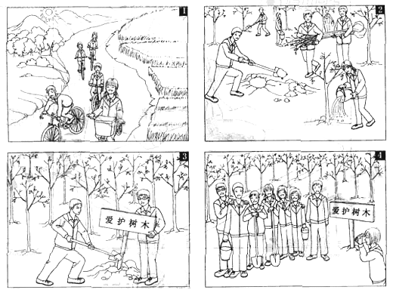

**2017 北京高考英语作文分类指导 记叙类2**

第二节 情景作文（20分）

假设你是红星中学高三一班的学生李华，为校刊《英语园地》写一篇题为“Our Voluntary Activity”的英文稿件。请根据以下四幅图的内容，叙述在12月5日志愿者日当天，你们班到公交车站参加志愿者服务活动的过程。词数不少于60。稿件的开头已给出。

提示词：桶bucket

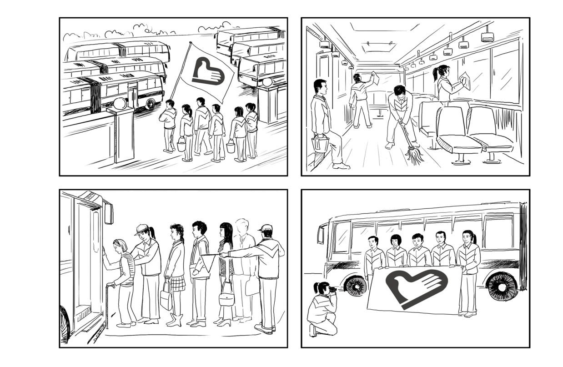

Our Voluntary Activity

December 5 was memorable because it was Volunteer Dan and we did some meaningful work.

**2017 北京高考英语作文分类指导 记叙类3**

海淀区高三年级第一学期期末练习**2016.01**

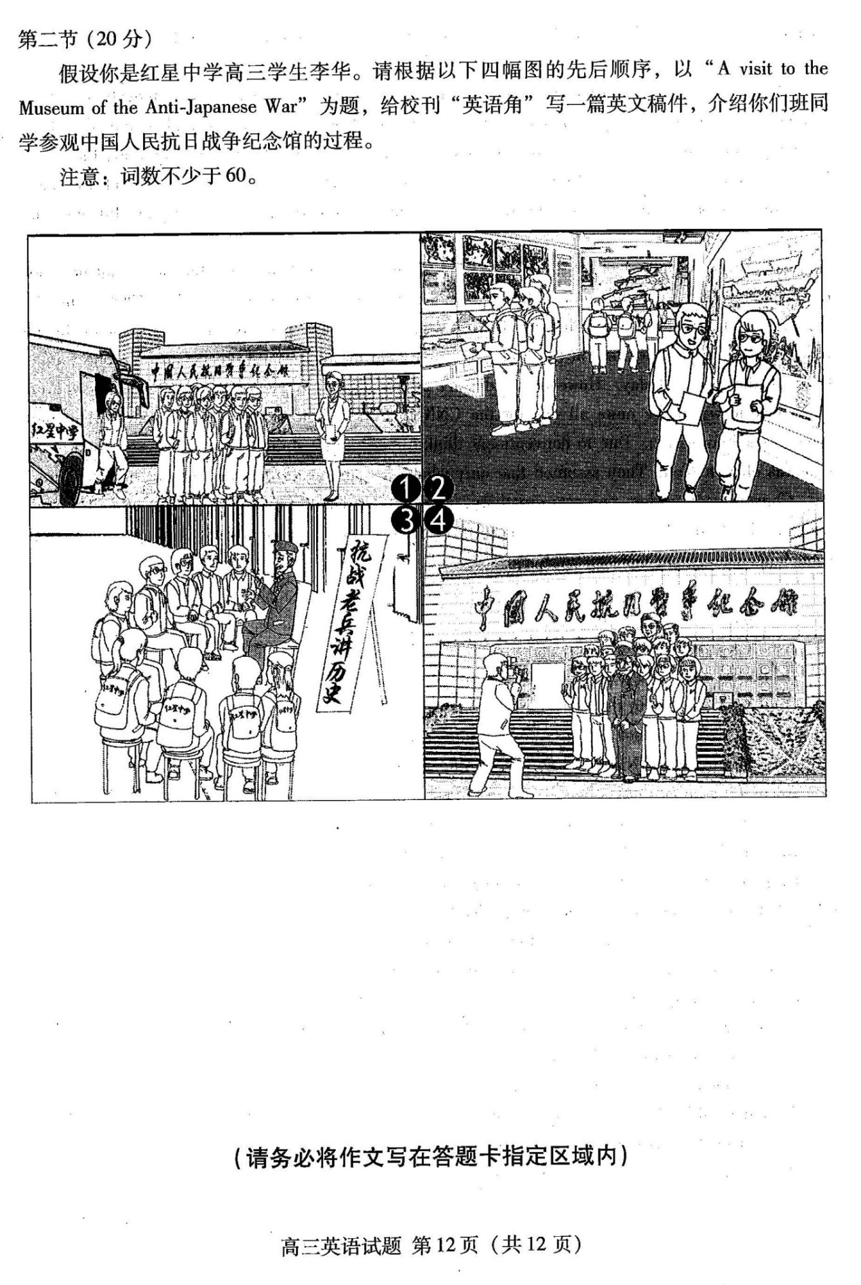

**2017 北京高考英语作文分类指导 记叙类4**

**海淀区高三一模 2016.4**

第二节 （20分）

假设你是红星中学高三学生李华。请根据以下四幅图的先后顺序，给校刊“英语园地”写一篇短文，介绍上周你与外国朋友Tom在颐和园的经历。

注意：词数不少于60。

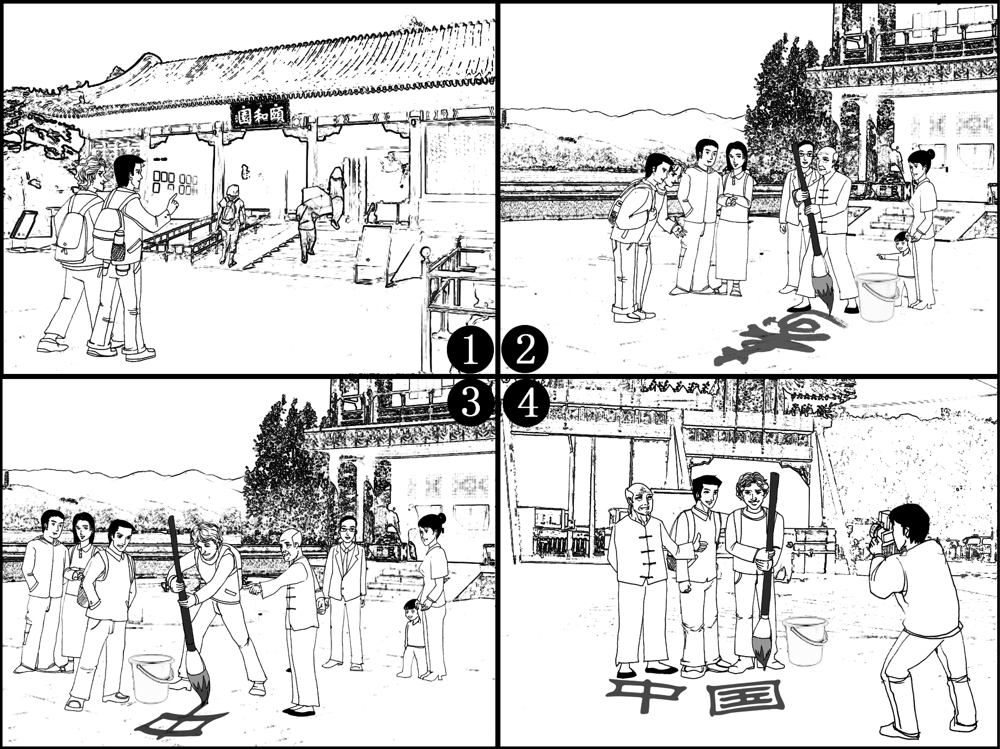 提示词：毛笔 a writing brush

**2017 北京高考英语作文分类指导 记叙类5**

第二节（20分）

假设你是红星中学的学生李华。请根据以下四幅图的先后顺序，用英文写一篇周记, 记述上周日你和父母一起骑车郊游的过程。

注意： 词数不少于60。 提示词: 郊区 the suburbs



**2017 北京高考英语作文分类指导 记叙类6**

**海淀区高三年级第一学期期中试题** **2015.11**

第二节（20 分）

假设你是红星中学高三学生李华。上个周末，为了给校的外籍学生营造学习中国文化的氛围，你们班布置了一间“中国小屋”，做为他们日常学习和活动的教室。请根据以下四幅图的先后顺序，介绍这一过程，并向校刊“英语园地”投稿。

注意：词数不少于60。

提示词：中国小屋 Chamber of China

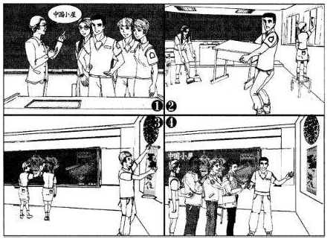

1. **北京高考英语作文分类指导 记叙类1**

内容要点：骑车去植树、植树、安插提示牌、照相

Green Action in Our Class

April 12 is memorable because our class had a meaningful experience on that day. In the morning, we bicycled to the suburbs to plant trees, talking and laughing all the way. Upon arrival, we began to work immediately. Some were digging holes. Some were carrying and planting young trees. Others were watering them. After getting the work done, we put up a board reminding people to protect the trees. Before leaving we took some photos to record our green action. Seeing the lines of trees, we all had a sense of achievement.

We feel it’s our duty to protect and beautify our environment.

**2017 北京高考英语作文分类指导 记叙类2**

**Our Voluntary Activity**

***December 5 was memorable because it was Volunteer Dan and we did some meaningful work.***

**After class we went to a nearby bus station with some buckets and our volunteer logo. Upon arrival, we began to clean the buses immediately. Some were carrying water. Some were wiping the floor of the buses. Others were cleaning the windows. After that, we tried to lead passengers to queue for getting on buses. Some even helped the old onto the bus. Before leaving we took some photos to record our voluntary activity holding a flag with the logo，which, I think, is the best explanation for our activity: try to give others a hand as much as possible.**

**2017 北京高考英语作文分类指导 记叙类3**

第二节（20分）

内容要点： 1．到达；2．参观；3．听故事；4．合影。

Last Saturday, our class visited the Museum of the Anti-Japanese War.When our school bus arrived at the Museum, we got off and entered in line. The moment we went into the exhibition room, we were attracted bythe pictures and descriptions about the war on the wall. Some students took notes while others had a little discussion. We were shocked at the cruelty of the war. Then we gathered in another room and listened to an old soldier telling the stories about the war. Therefore, we had a better understanding of the history.

Before we left, we all came to the front of the museum and took a picture with the old soldier in memory of our visit. We were very glad to meet such a true hero.

We hope by visiting the museum more people can remember what happened in the war and treasure the peaceful life.

**2017 北京高考英语作文分类指导 记叙类4**

第二节（20分）

内容要点： 1．到达颐和园； 2．看到写字； 3．学习写字； 4. 合影留念。

Last weekend, Tom and I paid a visit to the Summer Palace, which proved to be very interesting and rewarding.

We arrived at the entrance early in the morning and I introduced the history of the park to Tom briefly. The moment we entered the park, Tom was attracted by the beautiful scenery and we walked along the beautiful lake happily. Soon, we noticed an elderly man practicing calligraphy on the ground, with a bucket of water aside. Holding a big writing brush in his hand, he wrote the Chinese character for “longevity”. As well as other tourists, we couldn’t help but admire his skills.

To our surprise, the elderly man invited Tom to have a try. With his help, Tom completed his first calligraphy task, the two Chinese characters for “China”, quite successfully. Before we left, we took a photo together to memorize this valuable experience. In the picture, Tom held the writing brush and the elderly man smiled, with his thumb up.

I was so glad that I could help my foreign friend to learn about the art of the language we have been using for several thousand years. In addition, I rediscovered the charm of Chinese culture.

**2017 北京高考英语作文分类指导 记叙类5**

答案无

**2017 北京高考英语作文分类指导 记叙类6**

第二节（20分）

To help the international students understand Chinese culture better, our school decided to setup a “Chamber of China”.In the morning, the teacher assigned us to decorate the room. We felt quite excited and started soon. We first moved the desks and chairs away and cleaned the classroom thoroughly. After that, we began to decorate the room. Some of us put up the traditional paper cut “Fu” and also Chinese painting on the wall while others drew the Great Wall and lanterns on the blackboard. Everybody was working in high spirits.

The next day, the international students came to the chamber and were amazed to see the decorations. Their praise and thanks gave us a great sense of achievement.