2004-2014 年全国英语高考卷 1,2 作文范文

|  |  |  |
| --- | --- | --- |
| 年份 | 主题 | 高考英语作文 |
| 2004年 | 邀请外国学生报名参加才艺大赛,告知信息 | [2004年全国卷I高考英语满分作文：给美国朋友的信](http://gaokao.koolearn.com/20150127/842711.html) |
| 借宿你家表欢迎并安排流程 | [2004年全国卷II高考英语满分作文：给朋友的信](http://gaokao.koolearn.com/20150127/842712.html) |
| 2005年 | 询问旅游广告信息的完整性 | [2005年全国卷I高考英语满分作文：英文电子邮件](http://gaokao.koolearn.com/20150127/842703.html) |
| 动物园是否迁址：正反两方面观点 | [2005年全国卷Ⅲ高考英语满分作文：就动物园搬迁问题](http://gaokao.koolearn.com/20150127/842707.html)给报社的信 |
| 2006年 | 写信介绍自己的情况 | [2006年全国卷I高考英语满分作文：申请志愿者](http://gaokao.koolearn.com/20150127/842698.html)的信 |
| 根据图片给出信息进行描述 | [2006年全国卷II高考英语满分作文：图书馆介绍](http://gaokao.koolearn.com/20150127/842699.html)的信 |
| 2007年 | 根据条件描述理想中笔友，理由 | [2007年全国卷I高考英语满分作文：](http://gaokao.koolearn.com/20150127/842732.html)找笔友 |
| 把给出旅馆信息变成英文说明广告 | [2007年全国卷II高考英语满分作文：宾馆英语介绍](http://gaokao.koolearn.com/20150127/842733.html) |
| 2008年 | 根据信息完成作文， | [2008年全国卷高考英语满分作文：给动物园工作人员的信](http://gaokao.koolearn.com/20150127/842724.html) |
| 根据信息完成回信，怎样学习英文 | [2008年全国卷高考英语满分作文：](http://gaokao.koolearn.com/20150127/842730.html)怎样学英文的回信 |
| 2009年 | 告知几个事情的留言条 | [2009年全国卷I高考英语满分作文：英语留言条](http://gaokao.koolearn.com/20150127/842717.html) |
| 介绍前门大街位置交通特色等 | [2009年全国卷I高考英语满分作文：](http://gaokao.koolearn.com/20150127/842722.html)回信介绍前门大街改造情况 |
| 2010年 | 邀请当评委，并且通知相关时间安排 | [2010年全国卷I高考英语满分作文：](http://gaokao.koolearn.com/20150127/842753.html)写信邀请当评委 |
| 学习招聘外教，告知其招聘要求 | [2010年全国卷II高考英语满分作文：](http://gaokao.koolearn.com/20150127/842759.html)写信告知招聘信息 |
| 2011年 | 向语言辅导中心寻求帮助 | [2011年](http://gaokao.koolearn.com/20150127/842760.html)全国卷I高考英语满分作文：向语言辅导中心寻求帮助 |
| 根据提供信息给主编写信 | [2011年](http://gaokao.koolearn.com/20150127/842761.html)全国卷II高考英语满分作文：给主编的信 |
| 2012年 | 夏令营申请信 | [2012年全国卷I高考英语满分作文：](http://gaokao.koolearn.com/20150127/842770.html)申请参加夏令营 |
| 告知生日party相关消息，邀请来参加 | [2012年全国卷II高考英语满分作文：](http://gaokao.koolearn.com/20150127/842771.html)生日party邀请信 |
| 2013年 | 说明自己情况，方便找到借机 | [2013年全国卷I高考英语满分作文：](http://gaokao.koolearn.com/20150127/842753.html)问朋友是否可以借机的信 |
| 介绍代买情况，多少钱，怎么算 | [2013年全国卷II高考英语满分作文：](http://gaokao.koolearn.com/20150127/842759.html)请朋友代买中国节 |
| 2014年 | 和05年题型类似-询问信息完整性 | [2014年全国卷I高考英语满分作文：](http://gaokao.koolearn.com/20150127/842753.html)请给该校写封信，询问有关情况 |
| 从家庭，工作，业余生活展开 | [2014年全国卷II高考英语满分作文：](http://gaokao.koolearn.com/20150127/842759.html)十年后的我 |
| 2015年 | 告知 栏目介绍;  稿件内容长度和交稿日期等信息 | [2015年全国卷I高考英语满分作文：](http://gaokao.koolearn.com/20150127/842753.html)请给美国朋友彼得写信约稿 |
| 告知时间活动流程等 | [2015年全国卷II高考英语满分作文：](http://gaokao.koolearn.com/20150127/842759.html)邀请去外教去敬老院的信 |

2004 年高考英语全国卷 I

假设你是李华，你在报上看到北京电视台今年七月将举办外国人“学中文，唱中文歌”才艺大赛。你的美国朋友Peter正在北京一所大学学中文，你觉得他应去试一试。请按以下要点给他写信告知此事，并表示可以提供帮助。比赛时间：7 月18日

报名时间：截止到6月30日

报名地点：北京电视台

注意：

1.词数：100左右

2.可适当增加细节，以使行文连贯

3.参考词汇：才艺大赛-talent show

Dear Peter, I read in a newspaper today that a ―Learn Chinese, Sing Chinese Songs‖ Foreigners’ Talent Show will be held in Beijing Television Station on July 18. I know you like singing, and you are in Beijing during that period. I think this is a good chance for you to show your singing talent, and how well you’ve learned Chinese. If you would like to try, you have to go to the TV station to sign up before the end of June. If there is anything I can do for you, I would be more than glad to help.

2004 年高考英语全国卷 II

假设你是李华，加拿大一所学校将于今年暑假组织学生来你校访问。其间，Andy Smith将借住你家。请你代表全家写信给Andy，欢迎他的到来，并告知有关事宜。信的要点如下：

● ※ 上午：学校活动

● ※ 下午：游览市区

● ※ 晚上：看电视，玩游戏，聊天

● 注意：1．词数：100左右

● 2．可适当增加细节，以使行文连贯

● 3，参考词汇：安排—arrange

Dear Andy, I am glad to learn that you are coming to China and will stay at my home. My parents and I are very pleased to have you with us. Now let me tell you what we have arranged for you. I know the school will organize a lot of things for you to do in the morning, but in the afternoon, I’ll show you around and take you to some places of interest. We’ll mostly stay at home in the evening watching TV, playing games, and meeting people. I’m sure we’ll have a wonderful time and enjoy each other’s company. I’m looking forward very much to meeting you soon.

2005 年高考英语全国卷 I

假定你是李华，正在英国牛津参加短期语言培训，计划星期天去伦敦旅游。互联网上一则广告引起了你的注意，但一些具体信息不明确（箭头所指内容）。请给该旅行社发一封电子邮件，询问有关情况。

注意：1．词数100左右，信的格式已为你写好。

2．可根据内容要点适当增加细节，以使行文连贯。

3．参考词汇：牛津——Oxford 费用——fee



Dear Sir/Madame, I’m writing for more information about the day tour to London. As a student at Oxford University, I’d like to know if you have any special price for students. As for the money you charge, does it cover the entrance fees for visiting the places listed? What about lunch? Is it included? Or do I need to bring along my own food? How long will the tour last? Since I need to prepare my lessons for the next day, I’d like to know the time to return. Besides, is there any time for shopping? I really want to have a look at the big stores in London.

2005 年高考英语全国卷 II

假设你是李华，最近国内一家英文报纸正在讨论北京动物园是否应迁出市区。以下是你所在班级讨论的情况。请你给该报写一封信，反映讨论结果。

|  |  |
| --- | --- |
| 赞成迁出： | 反对迁出： |
| 1. 游客多，交通堵塞  2. 郊区环境好 | 1. 建于1906年，中外闻名  2. 搬迁易造成动物死亡 |

注意：

1. 词数100左右，信的开头已为你写好。

2. 可根据内容要点适当增加细节，以使行文连贯。

3. 参考词汇： 郊区—suburb

June 3, 2005

Dear Editor, Recently, our class have had a heated discussion about whether the Beijing Zoo should be moved out of the city. Some of my classmates are in favor of the move. They say large crowds of tourists to the zoo will result in traffic jams. They also say that once moved, animals will have more space and better living conditions in the suburbs. However, other students are against the idea, saying that the Beijing Zoo, built in 1906, has a history of 100 years, and is well–known at home and abroad. So it should remain where it is. What’s more, moving may cause the death of some animals. Whether to move or not, this is a big decision which has to be made by people in Beijing.

2006 年高考英语全国卷 I

假定你是李华。应英国朋友Bob的要求，写一封短信介绍你校图书馆的基本情况。内容须包括下面两幅图中的相关信息。

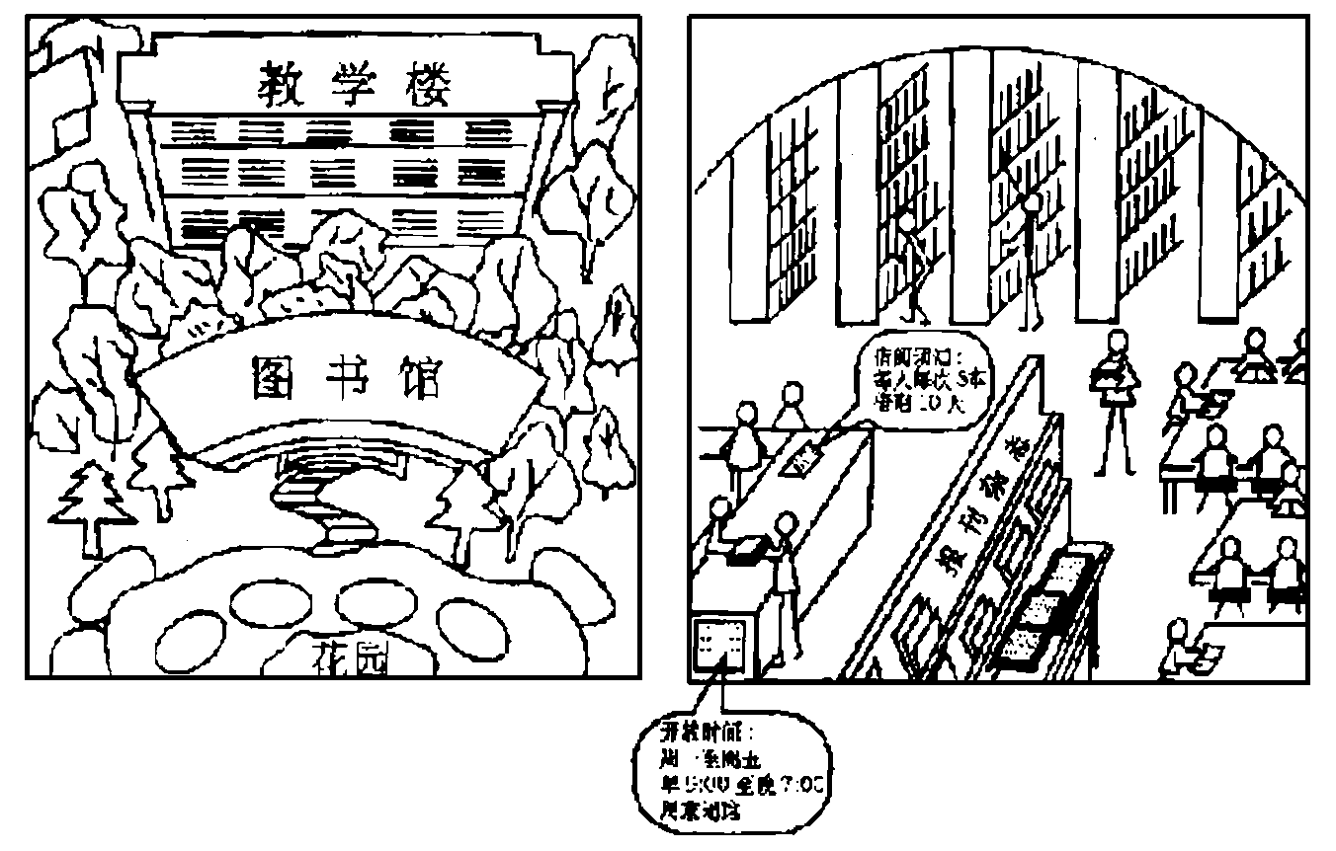

注意：1.词数100左右;

2.可以适当增减细节，以使行文连贯;

3.开头语已为你写好。

June 8

Dear Bob,

Thank you for your last letter asking about our library.

Best wishes,

Li Hua

Dear Bob, Thank you for your last letter asking about our library. Our library is the center of the school. There is a beautiful garden in front of it and our classroom building is right behind it. The library is big. When you get inside, you will see many shelves full of books on different subjects. There are also lots of newspapers and magazines. We borrow books and do some reading in the library. According to the rule, every student can borrow up to 5 books each time and keep them for 10 days. It is open from 9 am to 7 pm from Monday to Friday and closed on weekends. We all like our library very much.

2006 年高考英语全国卷 II

假定你是李华，亚洲冬季运动会将在你居住的地方举办，现正在招募志愿者，你希望成为其中一员。请按要求用英文给组委会写一封信。内容应包括：

1． 个人情况：年龄，性别，学历

2． 个人条件：英语好，爱好体育，善于交际，乐于助人，熟悉本地情况

3． 承诺：提供最佳服务

注意：

1． 词数100左右，开头语已为你写好

2． 可适当增加细节，以使行文连贯

3． 生词：申请—apply (v.),application(n.)

志愿者—volunteer

Dear Sir / Madam:

My name is Lihua .I would like to work as a volunteer for the Winter Asian Games.

Dear Sir / Madam, I was quite excited when I heard the Asian Winter Games will be held in the c ity I live. My name is Li Hua. I am an 18-year-old boy student in a senior middle school. And I want to be a volunteer for the games. I like English and sports very much. I like making friends and I am ready to help others. I can be a good interpreter in every sports during the time. Hope the games will be a great success. Hope I will be chosen to be one.

2007年高考英语全国卷 I

假定你是李华．希望通过外籍教师Peter找一位英语笔友。请写一封短信．描述一下你理想中笔友的条件，并说明为什么选这样的笔友。具体条件包括：

1．年龄

2．性别

3 ．爱好（旅游、运动、宠物等）。

注意： 1. 词数 100 左右；

2．可以适当增加细节．以使行文连贯；

3．开头语已为你写好。

Dear Peter,

I am writing to ask whether you are able to do me a favor.

Best regards

Li Hua

Dear Peter, I’m writing to ask whether you are able to do me a favor. I want to have a pen friend, hopefully a girl in her early twenties, and with interests similar to mine. In my mind, she is someone who is interested in travelling, swimming, and playing table tennis. Besides, it would be better for her to have a pet dog as I have kept one at home for some time. With such a pen friend, I hope I can share with her our experiences in travelling, taking care of pets, or whatever we have in common. And I believe I will improve my English by doing so and learn more about her country. I am looking forward to hearing from you soon.

2007 年高考英语全国卷 II

一家宾馆新开业，为吸引外国宾客，希望在互联网上进行宣传，请你用英语为其写一篇文字介绍。主要内容应包括：

1．地点：距白山人口处500米；

2．房间及价格：单人间(共20间)，100元／天；

双人间(共15间)，150元／天；

热水淋浴；

3．餐饮：餐厅(中、西餐)，咖啡厅(茶、咖啡)；

4．游泳池：全天免费开放；

5．欢迎预定。

注意：

1．词数100左右，开头语已为你写好；

2．可适当增加细节，以使行文连贯。

Welcome to Baishan Mountain Hotel

Baishan Mountain Hotel is now open for business.

Welcome to Baishan Mountain Hotel Baishan Mountain Hotel is now open for business. Our hotel stands 500 meters away from the entrance to Baishan Mountain. It has 20 single rooms and 15 double rooms, all with hot showers. A single room is 100 Yuan and a double room 150 Yuan for one night. You are advised to book in advance. The hotel serves three meals a day and there are Chinese food and western food for you to choose from. You can also enjoy yourself at the cafe drinking tea or coffee in the evening. We also have a swimming pool, which is open all day and free of charge. All are welcome!

2008 年高考英语全国卷 I

假定你是李华，从小喜爱大熊猫（panda）,一直通过有关网站(website)关注三年前在美国圣迭哥动物园出生的大熊猫“苏琳”和她的母亲“白云”。现在苏琳即将三岁。请根据以下要点给动物园工作人员写一封信：

1、 自我介绍；

2、 祝贺苏琳生日；

3、 感谢工作人员；

4、 索取苏琳三岁生日照。

注意：1、词数100左右；

2、可以适当增加细节，以使行文连贯；

3、开头语已为你写好。

Dear Sir/Madam,

Greetings from China!

__________________________________________________________________________

______________________________________________________________________________

______________________________________________________________________________

______________________________________________________________________________

Yours truly,

Li Hua

Dear Sir/Madam, Greetings from China! I’m Li Hua, a student in Sichuan. I’ve been a panda lover since I was a child. About three years ago I was delighted to learn that Baiyun gave birth to her daughter Sulin and I’ve been watching her grow on your website,. Now she’s going to be three. I’d like to wish her a happy birthday and to express my thanks to you for your hard work, because of which Sulin and her parents are living a happy and healthy life in the US. By the way, could I have a photo of Sulin taken on her third birthday? Thank you very much in advance.

2008 年高考英语全国卷 II

假定你是李华, 你的英国朋友Peter来信向你咨询如何才能学好中文. 请你根据下列要点写回信.

要点: 1. 参加中文学习班;

2. 看中文书刊、电视；

3. 学唱中文歌曲；

4. 交中国朋友。

注意：1.词数100左右；

2. 可适当增加细节，以使行文连贯；

3. 开头语已为你写好。

June 8, 2008

Dear Peter,

I'm glad to recerve your letter asking for my advice on how to learn Chinese well. ____________________________________________________________________________________________________________________________________________________________________________________________________________________________________________________________________________________

Best wishes,

Li Hua

June 8, 2008

Dear Peter, I’m glad to receive your letter asking for my advice on how to learn Chinese well. Here are a few suggestions. First, it is important to take a Chinese course, as you’ll be able to learn from the teacher and practice with your fellow students. Then, it also helps to watch TV and read books, newspapers and magazines in Chinese whenever possible. Besides, it should be a good idea to learn and sing Chinese songs, because by doing so you’ll learn and remember Chinese words more easily. You can also make more Chinese friends. They will tell you a lot about China and help you learn Chinese. Try and write me in Chinese next time. Best wishes

2009 年高考英语全国卷 I

假定你是李华，正在英国接受英语培训，住在一户英国人家里。今天你的房东Mrs

Wilson不在家，你准备外出，请给Mrs Wilson写一留言条，内容包括：

1．外出购物

2．替房东还书

3．Tracy来电话留言：1)咖啡屋(Bolton Coffee)见面取消

2)此事已告知Susan

3)尽快回电

注意：1．词数100左右；

2．可以适当增加细节，以使行文连贯。

Mrs Wilson, I’m going out shopping, and won’t be back until about 5:00 pm. I have taken with me the two books you asked me to return to the City Library. At about 1 o’clock this afternoon, Tracy called, saying that she couldn’t meet you at Bolton Coffee tomorrow morning as she has something important to attend to. She felt very sorry about that, but said that you could set some other time for the meeting. She wanted you to call her back as soon as you are home. She has already told Susan about this change.

2009 年高考英语全国卷 II

假定你是李华，你的美国朋友sarah 打算暑期来北京旅游，来信询问改建后前门大街的情况。请你写封回信，简单介绍以下内容：

1. 简况：长800余米、600多年历史、300余家商铺；

2. 位置：天安门广场南面；

3. 交通：公共汽车17、69、59等路，地铁2号线；

4. 特色：步行街、当当车、茶馆、剧院等。

参考词汇：步行街 pedestrian street

当当车 trolley car

地铁 subway

注意：

1. 词数100左右；

2. 可以适当增加细节，以使行文连贯；

3. 开头语已为你写好，请将完整的回信书写在答题卡上。

Dear sarah.

Thank you for you letter asking about the rebuilt Qianmen street. Here is something about it.

Dear Sarah, Thank you for your letter asking about the rebuilt Qianmen Street. Here is something about it. Qianmen Street is a famous street of over 600 years old. Along this 800-metre street, there are more than 300 shops. As the street is in the center of Beijing, just to the south of Tian’anmen Square, it’s very convenient to get there by bus. You may take Buses No.17, 69 or 59.subway Line 2 has a stop there too. Qianmen Street is a pedestrian street, but there are trolley cars to take you not only to the shops, but also to theaters and teahouses where you can experience a truly Chinese way of life, I’m sure you’ll like it.

2010 年高考英语全国卷 I & 新课标卷

假设你是育才中学学生会主席李华。你校将举办一次英语演讲比赛(speech

contest)．希望附近某大学的外籍教师Smith女士来做评委。请参照以下比赛通知给她写

一封信。

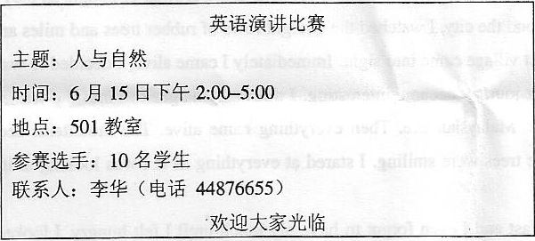

注意：词数100左右。

**************************************

Dear Ms. Smith,

With best wishes,

Li Hua

Dear Ms .Smith, I’m Li Hua. Chair of the Student Union of Yucai Middle School, which is close to your University. I’m writing to invite you to be a judge at our English speech contest to be held in our school on June 1st. It will start at 2:00 pm and keep for about three hours. Ten students will deliver their speeches on the given topic ―Man and the Nature‖. We hope you will accept our invitation if it is convenient for you. Please call me at 446765560 if you have any questions. I am looking forward to your reply.

2010 年高考英语全国卷 II

假设你是李华，你的美国笔友 Peter 层表示希望来中国教书。你校现在需招聘外教， 请给他写封信，告知招聘信息。内容主要包括： 1.教授课程：英语口语、英语写作、今日美国、今日英语等 2.授课对象：高中生（至少三年英语基础） 3. 工作量： — 每周 12 学时，任选三门课 — 担任学生英语俱乐部或英语校报顾问 （advisor）

Dear Peter, I remember you told me you were interested in teaching in China. Our school is looking for a native-speaker to teach some courses to senior students. If you come, you can choose three of the following four courses: Speaking, Writing, Britain Today and America Today, and teach 12 hours a week. The students who are going to take these courses have at least three years of English learning experiences. Besides teaching, you will also work as an advisor to our students’ English club or our school’s English newspaper. Please let me know if you are interested and if you have an y other questions. I’d be more than happy to help.

2011 年高考英语全国卷 I & 新课标卷

假定你是李华，正在一所英国学校学习暑期课程，遇到一些困难，希望得到学校辅导中心（Learning Center）的帮助。根据学校规定，你须书面预约，请按下列要点写一封信：

1.本人简介； 2.求助内容； 3.约定时间；

4.你的联系方式（Email:lihua@126.com;Phone:12345678）

注意：1.词数100左右；2.可以适当增加细节，以使行文连贯；

3.结束语已为你写好

Dear Sir/Madam, My full name is Li Hua, a student of summer courses here. I am writing this letter to report some of the problems and puzzles I encountered when learning the course of Business English. My puzzle is that I don’t know whether this course mainly teaches English or teaches in English. In other words, how could I balance between business knowledge and English itself? I hope you could give me some directions so that I can work it out without too much difficulty. I am available at 8 am on Wednesday. Would that be OK? Please do feel free to contact me by e-mail or telephone at any time. My email address is lihua@1236.com My phone number is 12345678. Look forward to your reply!

2011 年高考英语全国卷 II

假定你是李华，你所喜爱的Global Mirror周报创刊五周年之际征集读者意见．请你依据以下内容给主编写封信，内容主要包括：

1．说明你是该报的忠实读者

2．赞赏该报优点：

1)兼顾国内外新闻

2)介绍名人成功故事

3．提出建议：

刊登指导英语学习的文章

注意：

1．词数100左右，开头语己为你写好；

2.可以适当增加细节，以使行文连贯。

＊＊＊＊＊＊＊＊＊＊＊＊＊＊＊＊＊＊＊＊＊＊＊＊＊＊＊＊＊＊＊＊＊＊＊＊＊＊＊＊＊＊＊＊＊＊＊＊＊＊＊＊＊＊＊＊＊＊＊＊＊＊＊＊＊＊

Dear Editor-in-Chief,

Congratulations on,the,5'h anniversary,of Global Mirror!

_______________________________________________________________________________

Sincerely yours,

Li Hua

Dear Editor-in-Chief, Congratulations on, the, 5’h anniversary, of Global Mirror! I’m a regular reader of your newspaper. I like it very much mainly for the following two reasons. First, it covers both national and international news so that, by simply turning the pages, I can learn all important things that have happened during the week. Equally attractive are the success stories of world-famous people, which help me understand how a person can work hard to make the world a better place. As a young student, I suggest that Global Mirror carry articles to guide us in our English learning , and I hope that it will become even more popular.

2012 年高考英语全国卷 I

假定你是李华，从互联网上得知一个国际中学生组织将在新加坡((Singapore)举办夏令营，欢迎各国学生参加。请写一封电子邮件申请参加。

内容主要包括:

I.自我介绍(包括英语能力);

2.参加意图(介绍中国、了解其他国家);

3.希望获准.

注意:

1.词数100左右:

2.可以适当增加细节，以使行文连贯;

3.邮件开头和结尾已为你写好。

Dear Sir or Madam, I'm Li Hua, a middle school student from China. I read the announcement of the summer camp that you have posted on the Internet and I am interested in it. I know that you welcome students from different countries and I'd like to take part in it. I've been learning English for 10 years, and I speak fluent English. What is more, I'll be able to tell students from other countries about China and learn about their countries as well. I hope I will be accepted as a member of your summer camp. Looking forward to your reply!

2012 年高考英语全国卷 II

假定你是李华。你班同学决定为小明举办生日聚会。请你写信邀请外教Susan参加，要点包括：

　　⒈ 时间：周五晚8点至9点

　　⒉ 地点：学生俱乐部

　　⒊ 内容：生日歌、蛋糕、游戏等

　　⒋ 要求：备小礼物

　　注意：⒈ 词数100左右，开头语已为你写好；⒉可以适当增加细节，以便行文连贯；⒊ 答案必须写在答题卡相应的位置上。

　　Hi, Susan,

We're throwing a surprise party for Xiaoming's birthday．

Hi, Susan, We're throwing a surprise party for Xiaoming's birthday. We'd like to invite you to the party. We want to give him a surprise, so please keep quiet about it．We'll gather at the Students' Club at 8 p.m this Friday after the evening classes. And it's going to last about an hour.We each will prepare a little present When he comes, we'll light the candles and sing―Happy Birthday‖ together for him.Then the cake will be cut and we'll sing songs and play games.It'll be nice to see how excited he will be.I'm sure you'll have a good time at the party, too.

2013 年全国大纲卷、新课标 I

假定你是李华。请你给笔友Peter写封信，告诉他你叔叔李明将去他所在城市开会，带去他想要的那幅中国画，同时询问他是否可以接机。信中还需说明： 李明：高个子，戴眼镜 航班号：CA985 到达：8月6日上午11:30 注意：1. 词数100左右；2. 可以适当增加细节，以使行文连贯； 3. 开头语和结束语已为你写好。

Dear Peter, How are you doing? I am writing to tell you that my uncle Li Ming is going to your city for a conference, and I have asked him to bring you the Chinese painting you’ve asked for before. Also, I’d like you to do me a favor. Would you please meet my uncle at the airport and take him to his hotel since this is his first visit to the U.S.? Thank you in advance! His flight number is CA985, and it will arrive at 11:30 am, August 6. My uncle is tall and he is wearing glasses. And he will be in a blue jacket. Looking forward to your reply.

2013 年全国大纲卷、新课标 II

假定你是李华，自制一些中国结（Chinese knot）。给开网店的美国朋友Tom写封信，请他代卖，要点包括： 1.外观（尺寸、颜色、材料） 2.象征意义 3.价格 注意：1.词数100左右； 2.可以适当增加细节，以使行文连贯； 3.开头语已为你写好。

How are you? I wonder if you could sell some Chinese knots for me. I made them myself with red silk threads, cloth and other materials. They look really beautiful in the shape of a diamond, about 5 inches long and 4 inches wide. In china, these knots stand for friendship, love and good luck. People can either give them as gifts to friends or hang them in their houses. They are only 12.99 US dollars each. If anyone wants to know more about the knots, let them write to me. Also, do let me know if you need further information. Thank you!

2014 高考英语作文全国卷 I

假定你是李华，计划暑假间去英国学习英语，为期六周。下面的广告引起了你的注意，请给该校写封信，询问有关情况（箭头所指内容）

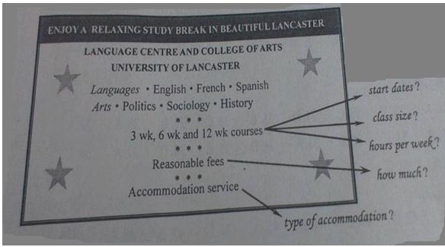

注意：1．词数100左右；

2．可以适当增加细节，以使行文连贯。

3．参考词汇：住宿-accommodation

Dear Sir/Madam, I am a student in China and I plan to go to Britain to attend a summer school during the vacation. I’ve seen your ad, and I’d like to know something more about your six -week English course. First, when will the course start and how many class hours are there per week? Besides, I wish there would not to be too many students in a class. I’d also like to know how much I have to pay for the course and whether accommodation is included. Would there be host family or university dormitory? I’m looking forward to your early reply.

2014 全国卷 II

一家英语报社向中学生征文，主题是“十年后的我”，请根据下列要点和你的畅想完成短文。

1.家庭：

2．工作：

3.业余生活。

注意：1.词数100左右：

2.可以适当增加细节，以使行文连贯：

3.开头语已为你写好。

I often imagine what my life will be like in the future. I think my life will be very different in ten years. I will be twenty-eight years old by then. I will have my own family, probably with a lovely child. I hope I will work in a computer company as a program designer. I’ll enjoy my work and get along well with my colleagues. I’ll do a good job in whatever I do. In my free time, I’ll continue to take regular exercise, such as swimming, running and various ball games. On my holiday, I’ll travel around the world. In a word, my life will be much richer and more colorful.

2015 全国卷 I

假定你是李华, 你校英文报“外国文化”栏目拟刊登美国节日风俗和中学生生活的短文。请给美国朋友彼得写信约稿, 要点如下:

1. 栏目介绍;  2. 稿件内容;  3. 稿件长度: 约400词汇;  4. 交稿日期: 6月28日前天  注意: 1. 词数100左右;  2. 可以适当增加细节, 以使行文连贯的;  3. 开头语已为你写好。

Dear Peter, I‟d like to ask you to write an article for our school‟s English newspaper. The “Foreign Culture” section in our newspaper is very popular among us students. It carries articles written by foreign friends about the cultures of their home countries. Would you please write something about the culture in your part of the the United States? And we would specially welcome articles about how Americans spend their holidays and festivals, and the life of American high school students. You can write anything relevant so long as it‟s interesting and informative. 400 words would be fine. Could we have your articles before June 28? I‟m looking forward to hearing from you. Yours, Li Hua

2015 全国卷 II

假如你是李华，计划和同学去敬老院（nursing home）陪老人们过重阳节（the Double Ninth Festival）。请给外教露西写封邮件，邀她一同前往，内容包括： 1.出发及返回时间；

1. 活动：包饺子、表演节目等。
2. 注意：

1.词数100左右；

1. 可以适当增加细节，以使行文连贯；
2. 3.结语已为你写好。

Dear Lucy,

     I’d like to invite you to join us for a visit to the nearby nursing home next Saturday for the Double Ninth Festival. It is the day for the elderly in our culture. We’ll go and make dumplings and cakes with the elderly people there. We’ll also spend some fun time together singing, dancing and playing games, which we hope will make them happy. We should be back around 4 o’clock in the afternoon. If you are able to come with us, please let us know and we’ll wait for you at the gate at 9 in the morning.

Looking forward to your reply. Yours  Li Hua